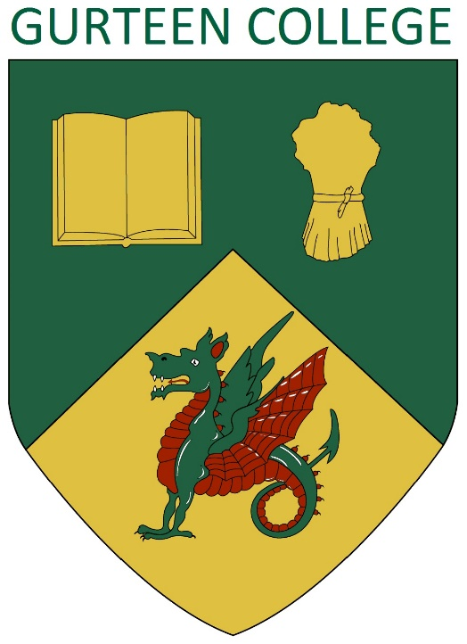
Deputy Principal

Reporting to: College Principal

Grade/Salary: Circa €70,000

Basic Function: Gurteen College are seeking applications for the role of Deputy Principal. The Deputy Principal is core member of the Gurteen management team, taking lead responsibility for all academic matters, with a clear focus on learner centred activities. The role will require an effective manager and strategic thinker, who can lead future curriculum development whilst also managing the teaching staff team and leading the quality assurance process.

Main Duties and Responsibilities

- Deputise for the Principal when they are unavailable
- Be a member of the College management team and actively participate in all aspects of College strategic and operational management.

- Lead the academic staff team

- Have oversight and responsibility for all aspects of academic quality assurance.

- Continuously review and develop the curriculum offered

- Act as the key point of contact for Governors on all academic matters, attending board meetings and presenting reports

- Ensure the Gurteen ethos and culture is reflected through all academic aspects

- Represent Gurteen at education partnership and industry stakeholder meetings

- Promote a student centred approach across all College activity

- Oversee the work of course coordinators

- Manage timetabling within the College and ensure effective and efficient staff utilisation

- Oversee the promotion of College courses.

- Lead the planning and delivery of new teacher induction and in-service training for teaching staff.

- Guide / assist the Placement Officers in managing the PLP/Industry Placement for students.

- Take lead responsibility for Whole College Evaluation

- Coordinate internal and external verification, and act as lead internal verifier.

- Organise and maintain, as required, proper records of student enrolment, attendance and examination results and learner satisfaction surveys.

- Ensure the provision is made for the general wellbeing of the college students.
- Establish codes of discipline for students and supervise their application.

- Ensure an effective student council provides a clear opportunity for the students to provide feedback and contribute to College planning

- Ensure health and safety best practice is implemented for College education and training activities.
- To undergo such training as may be required from time to time.

- To undertake such other duties and responsibilities as may be assigned from time to time

Competencies Profile
Interviews will be competency based and candidates will be required to demonstrate competency by way of examples in the following areas:

- Leadership Skills & Team work
- Organizing & Planning
- Effective Communication and Influencing Skills

Person Specification

 | ESSENTIAL | DESIRABLE
Qualifications | Level 8 degree | Relevant post graduate qualification
Skills | - Leadership  - Staff management  - Great Communicator  - Excellent Organizational skills.  - Ability to foster high work standards, discipline and accountability.  - A respected teacher | Experience of working with Moodle, Quercus, Banner and similar education software.
Knowledge | - Solid understanding of academic quality assurance processes.  - Good Knowledge of Equine & Agricultural Sectors | Experience as lead verifier or similar
Attributes | - Able to manage change  - Strategic thinker  - Good communicator (written and oral) and ability to motivate & inspire.  - Motivated by change and continuous improvement  - Commitment to the ethos and culture Gurteen College  - Strong learner centered focus.  - Results Orientated

HOW TO APPLY
Submit a CV and cover letter direct to info@gurteencollege.ie by midday on Monday 6th January 2025
For a confidential conversation or more information call Jon Parry on 087 7192747

